
Entrega 2 – Sprint 0 Product BackLog y UserHistory
William David Vivas Maldonado
Juan Sebastián Torres Florez
David Alejandro Bonilla Mahecha
Karen Juliana Medina Sanchez

Arquitectura de Software
Facultad de ingeniería
Bogotá D.C. Colombia
22 de febrero del 2026

Entrega 2
- Build the product backlog. Remember that the product backlog should be prioritized (You must use 2 ways to prioritize).
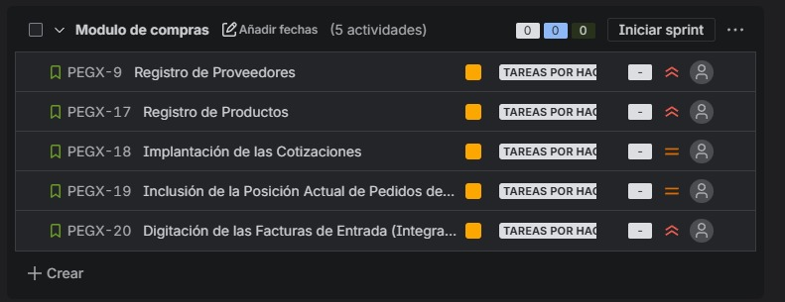
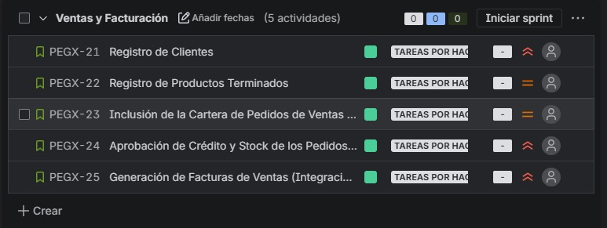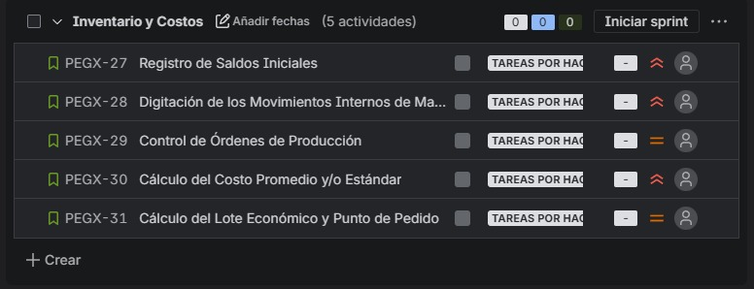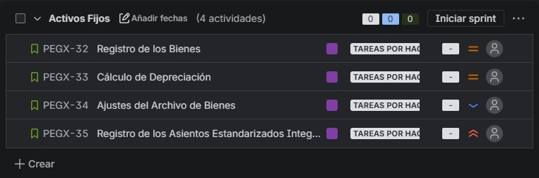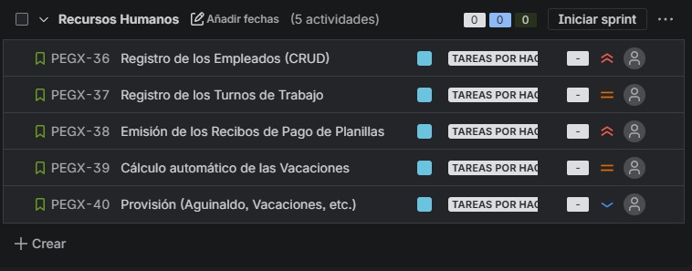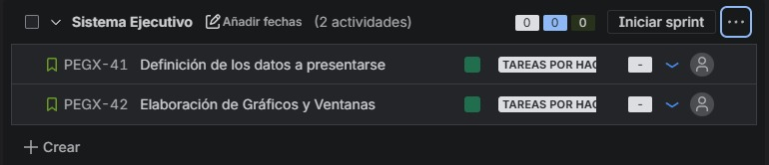
Tomamos la decisión de priorizar por dos medios parecidos y distintos entre sí, estos dos fueron el planning poker y moscow, esto es debido a que nos permite reconocer de maneras mas prácticas y interactivas la prioridad y dificultad de ciertas tareas.
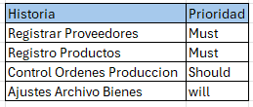
En la asignación de prioridad de moscow nos referimos a cuatro categorías must, shoul, could and will. Cada uno de estos va de mayor a menor, siendo must algo que necesita el desarrollo obligatorio, el should algo que puede ser, pero no es prioridad obligatoria, could se refiere a la parte que puede ser desarrollado, pero no es algo que sea necesario y el will es estaría bien, pero da igual.
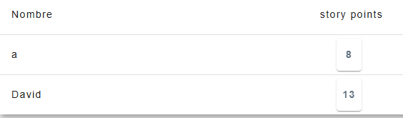
Esta imagen hace referencia a la decisión de puntos de usuario en un planning poker, se realiza un consenso tanto en el valor como complejidad por medio de ciertos valores de la secuencia de finobacci.

- Determine the “Definition of Done” established by the group for the development of the project
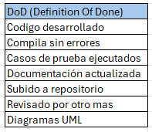
- Build the sprint backlog for the first sprint. For this:
- Make a detailed specification of the stories selected for the sprint
- Prioritize those user stories with the greatest value to the end user
- Include at least 5 acceptance criteria for each story
- Determine the tasks needed to complete the stories proposed for the sprint
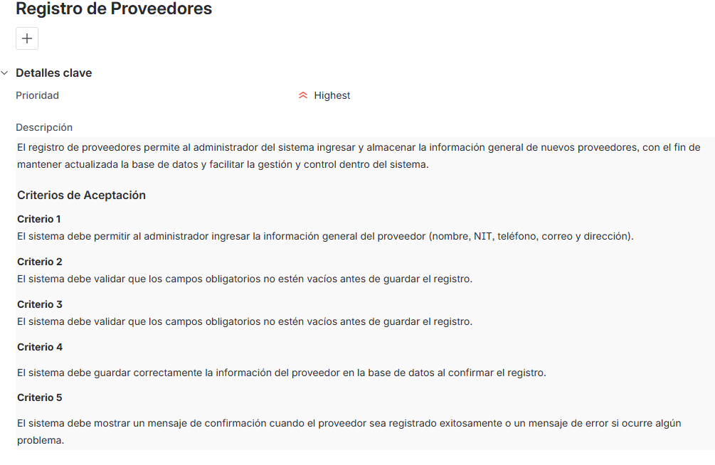
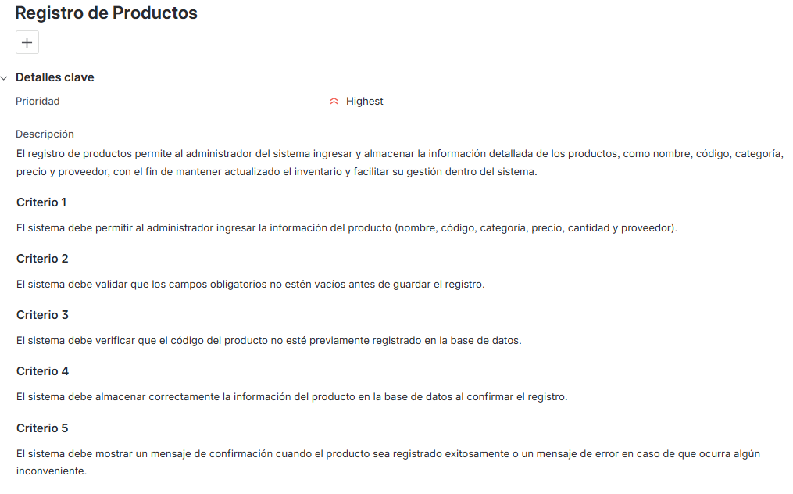
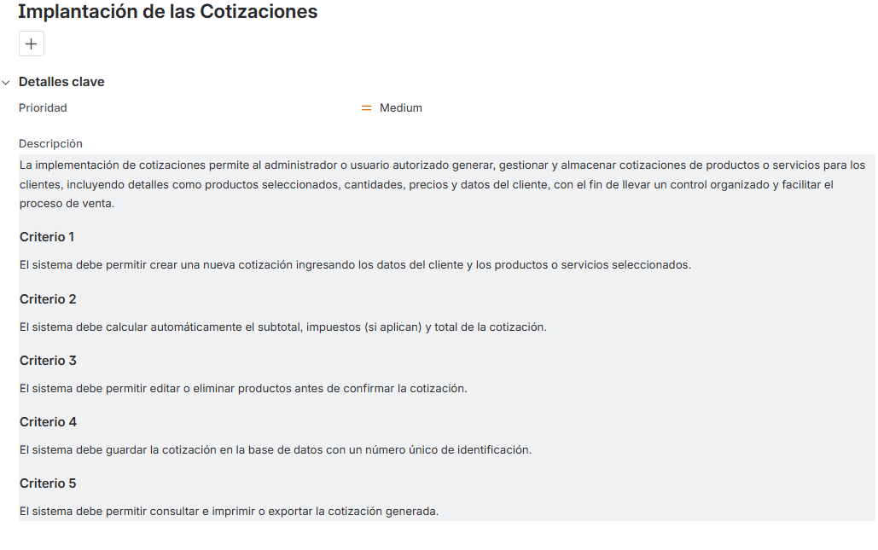
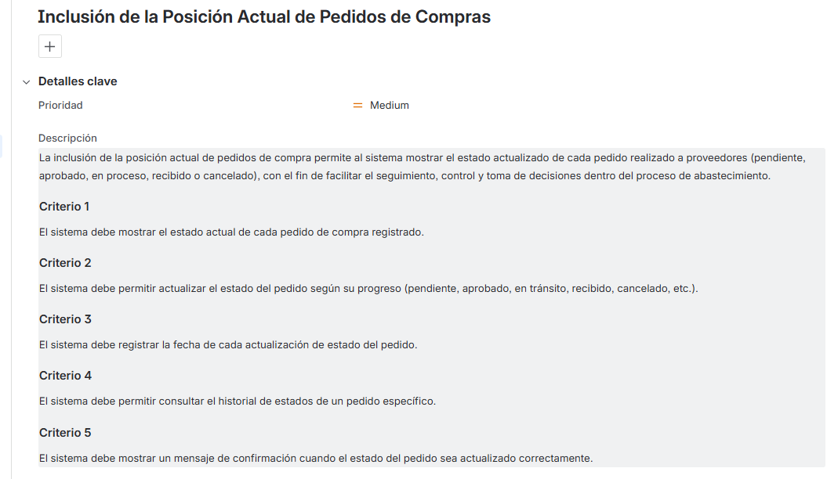
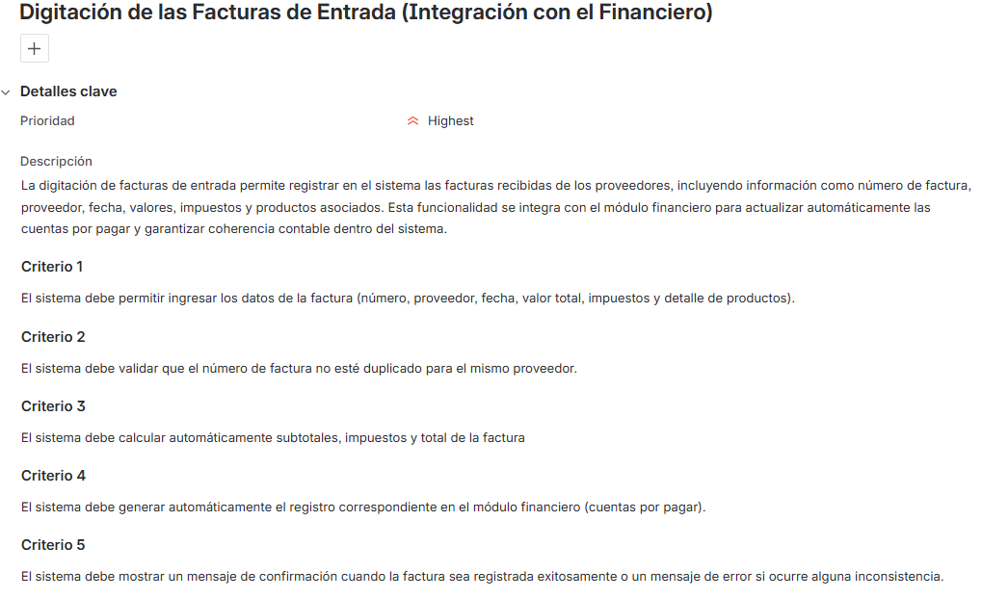
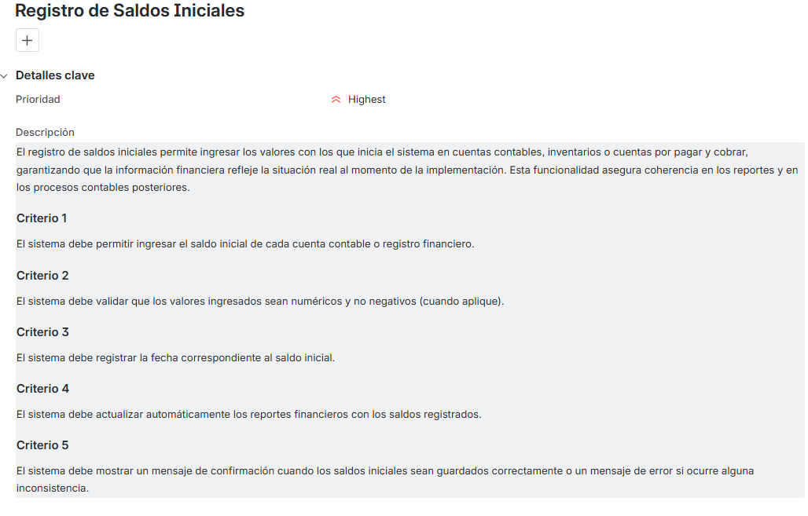
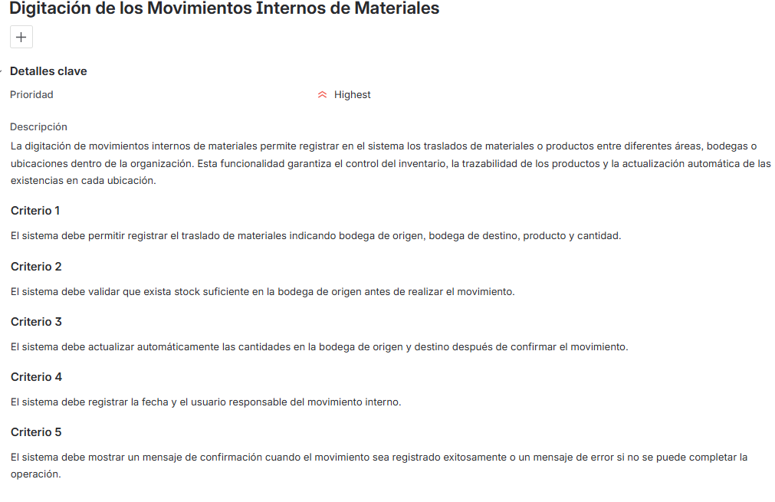
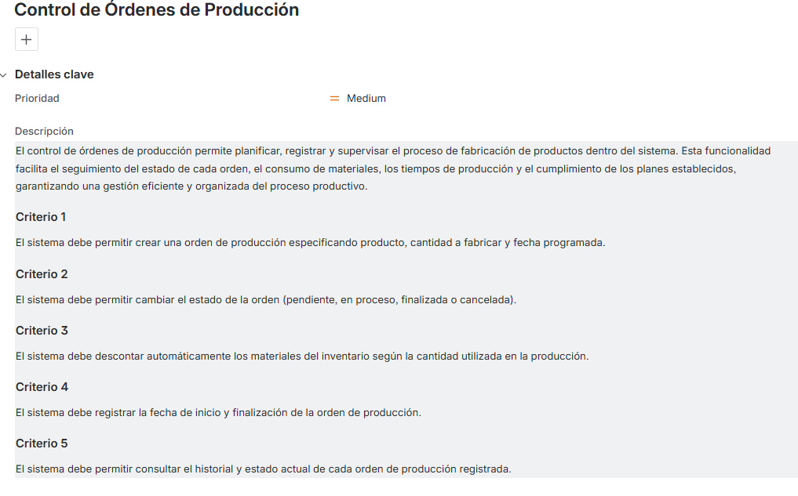
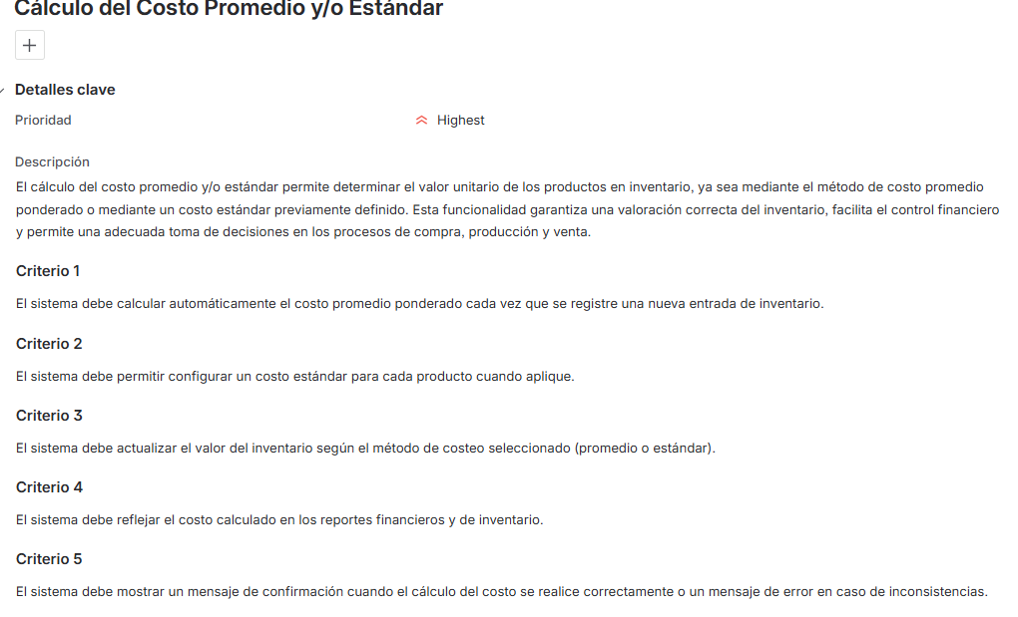
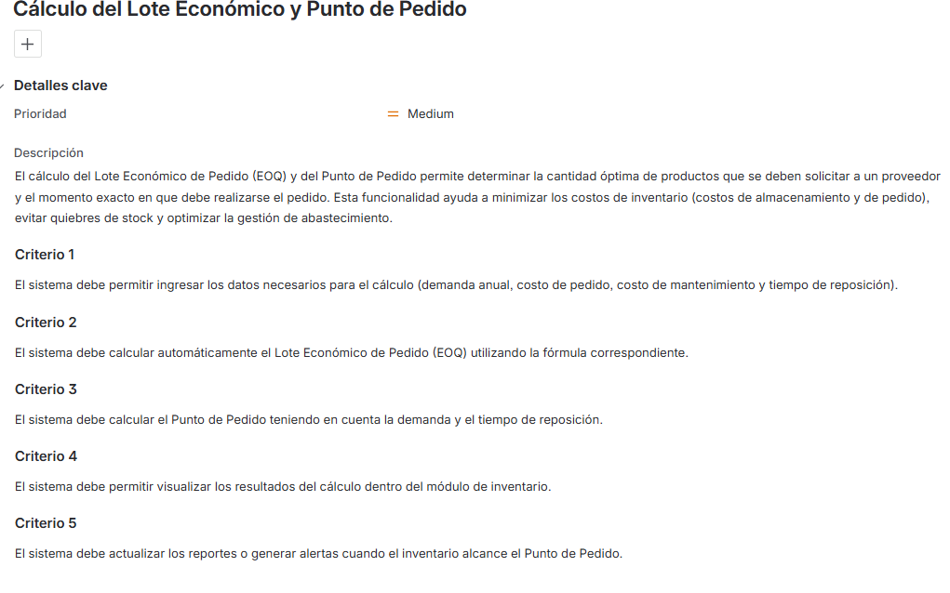
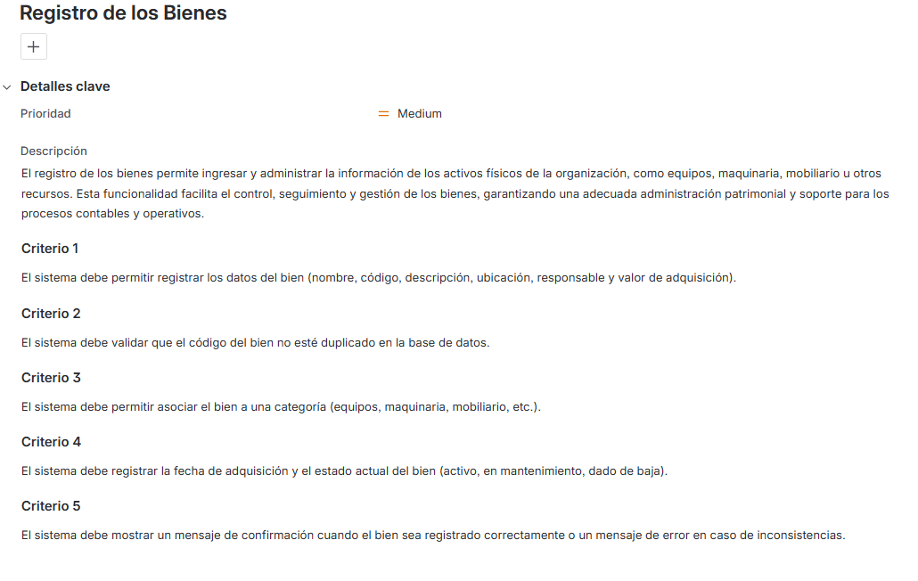
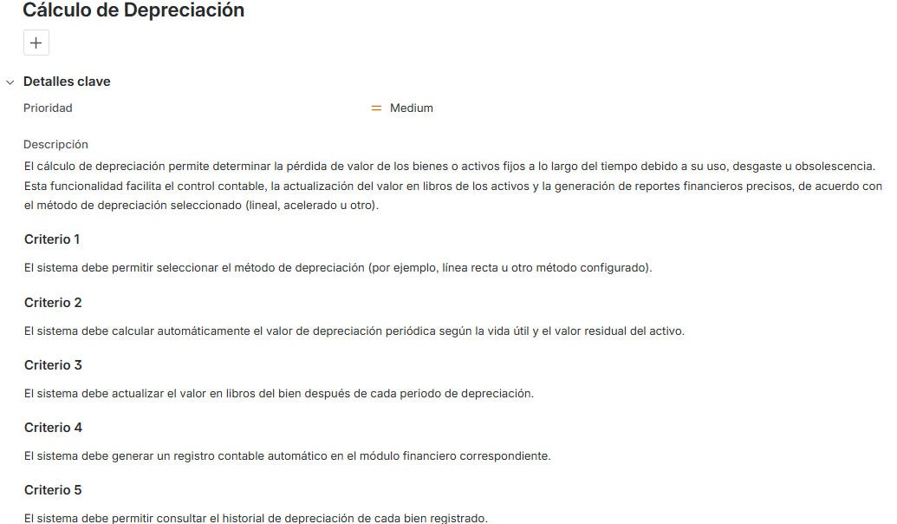
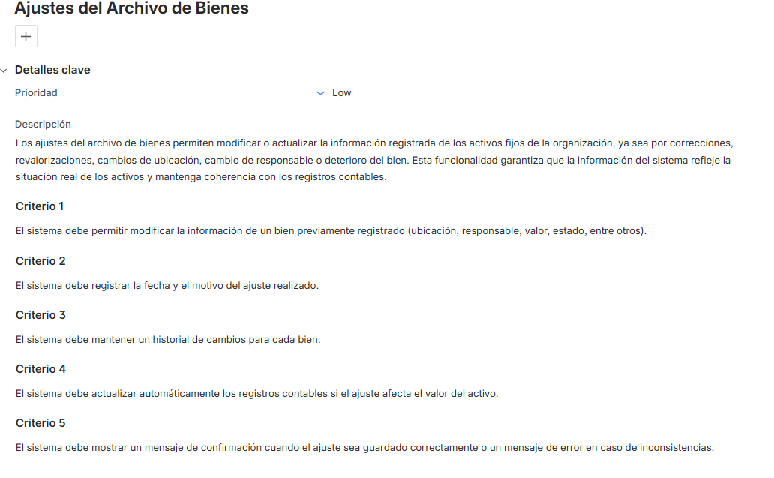
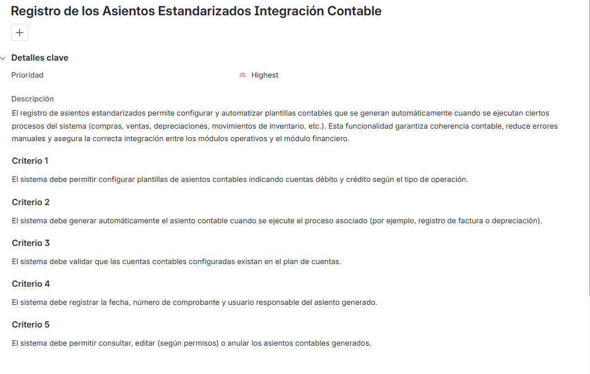

- Generate the effort estimate for each of the user stories according to their complexity. For this task it is suggested to use the planning poker strategy and allocate the weights using the Fibonacci series.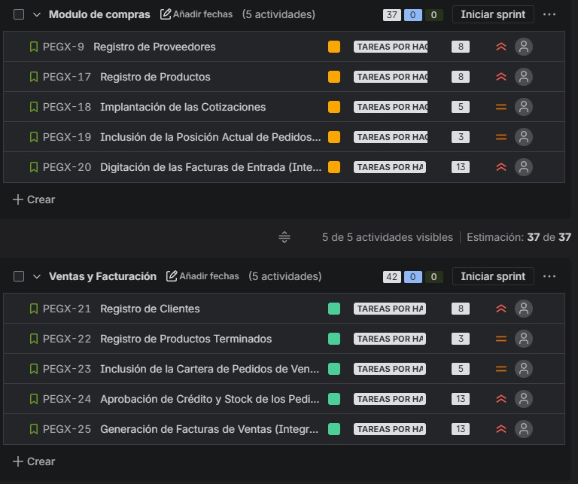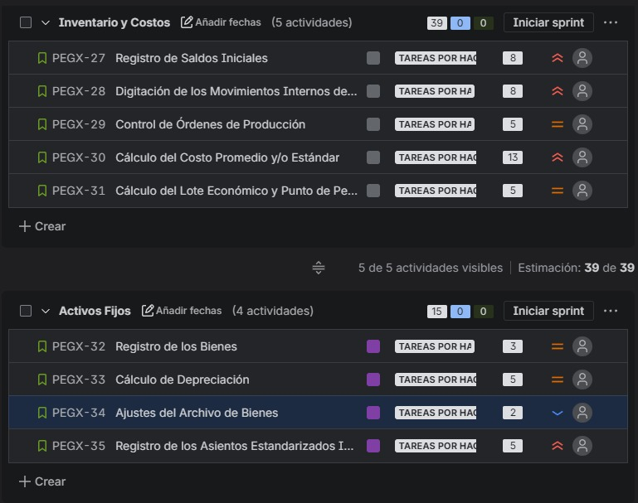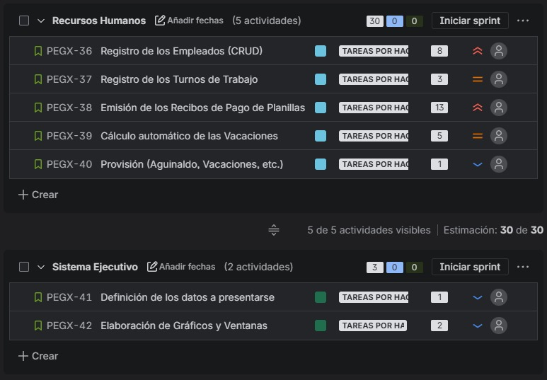

- Sprint test planning.
Test cases on selected platform (minimum 5 cases per user story)
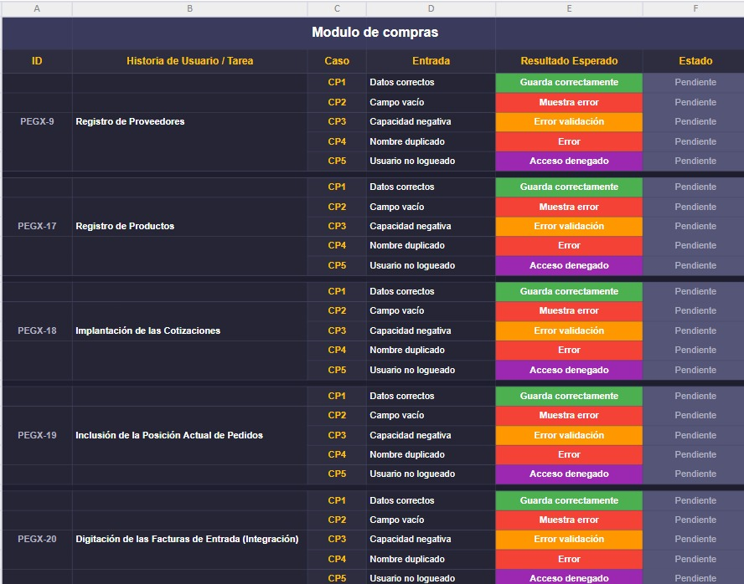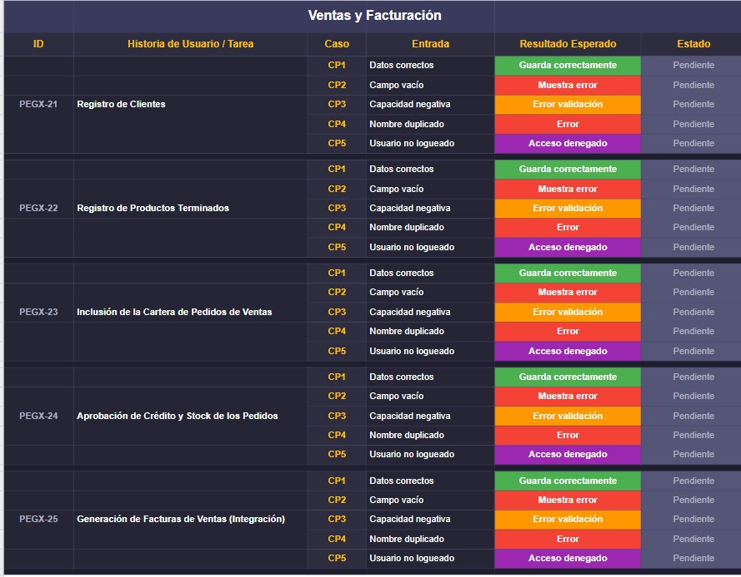
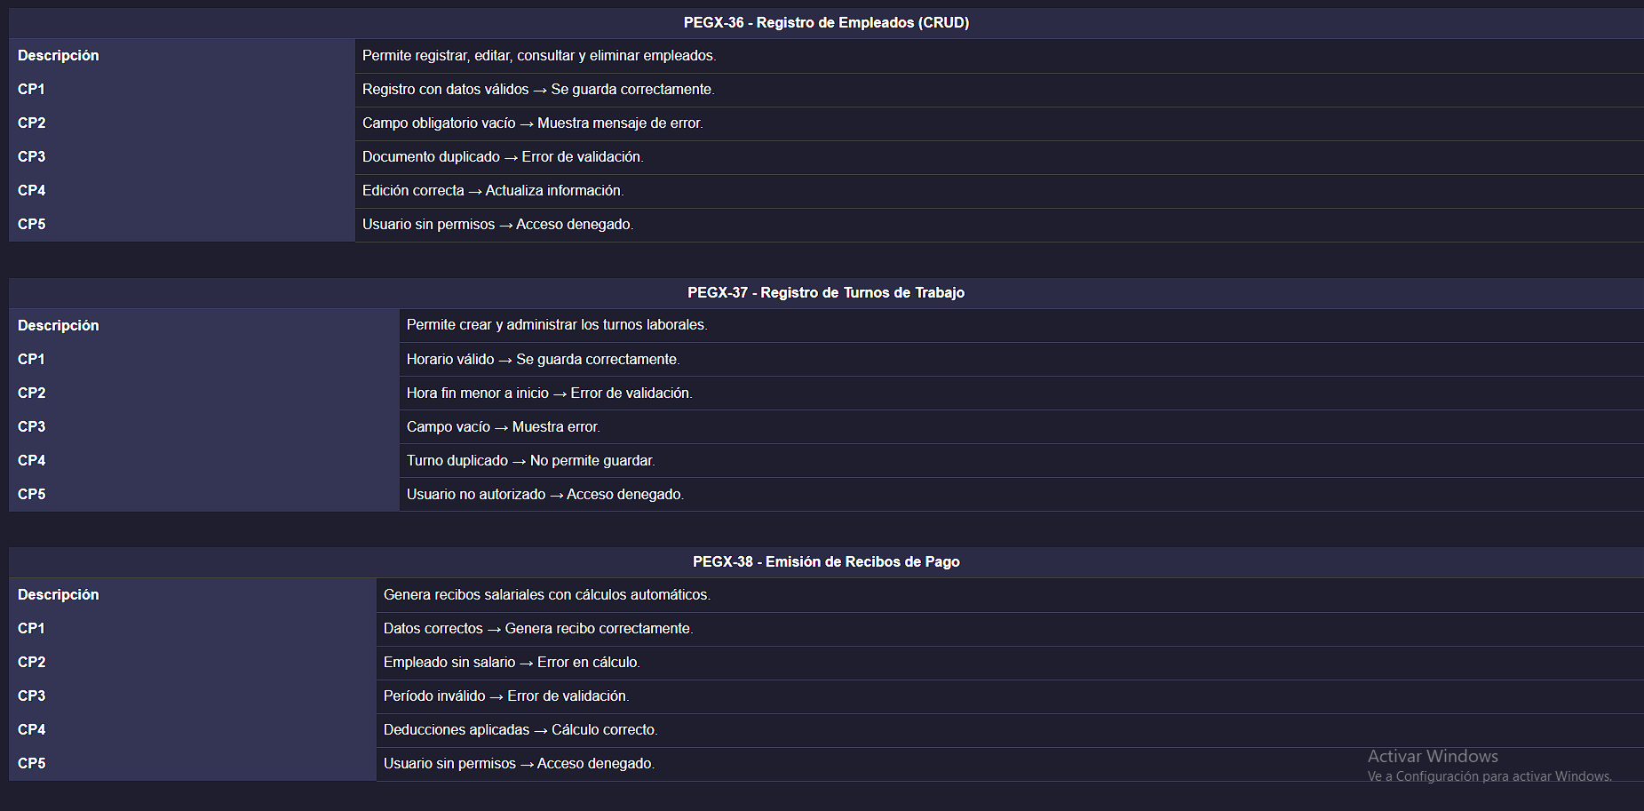
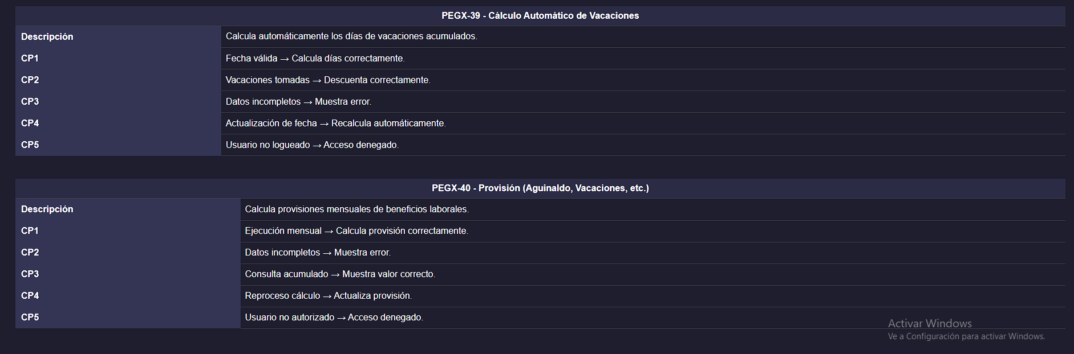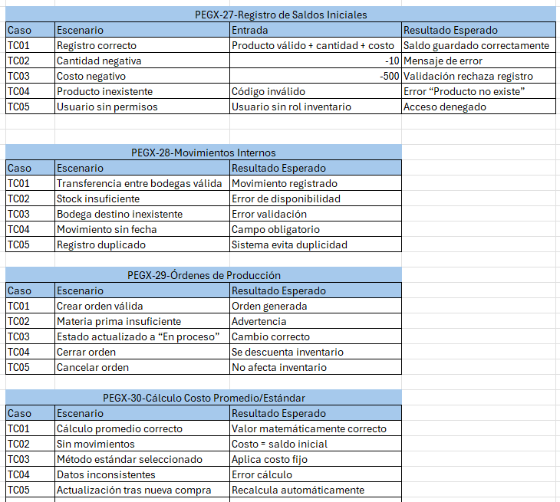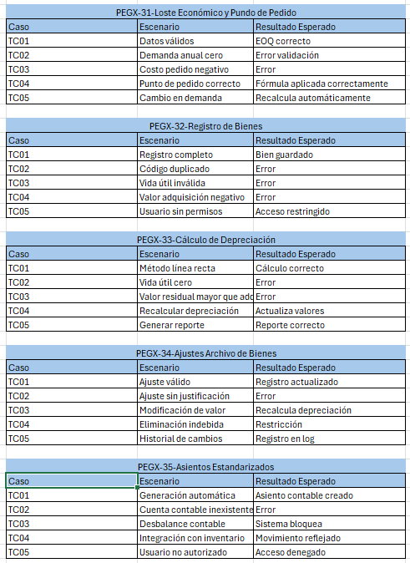
- Identify the strengths and weaknesses of each team member. It is suggested to assign roles to lead technical, organizational, and quality aspects. These elements are definitive in the success of the project and should be considered before starting development. Complete the following table mentioning the strategies established by the group in each case.
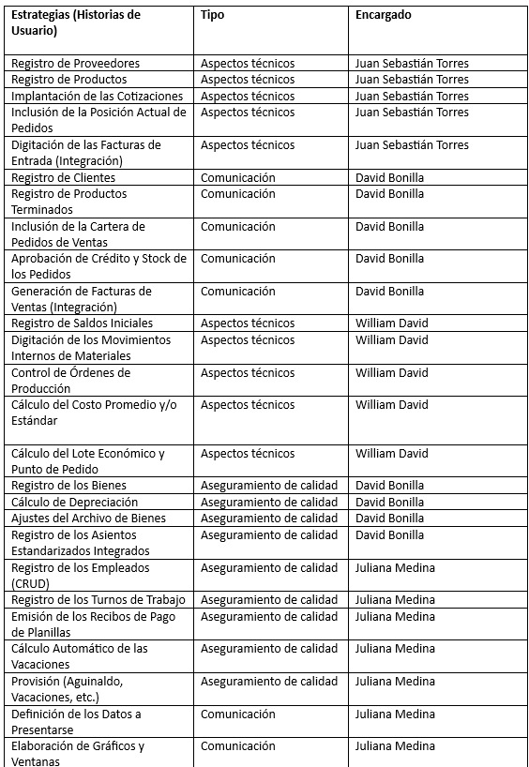

- Propose a work schedule for the execution of sprint. Please note the following:
- Integration and testing processes should be considered, as well as estimated completion dates for individual tasks.
- Generate planning on Jira or Github or Notion
- https://davincho3103.atlassian.net/jira/software/projects/PEGX/boards/2/backlog?epics=visible&selectedIssue=PEGX-21
https://github.com/Davincho3103-afk/erp-software-architecture

